**Introduction/Business Problem In a city of your choice, if someone is looking to open a restaurant, where would you recommend that they open it?**

As increasing numbers of consumers want to dine out or take prepared food home, the number of food-service operations has skyrocketed from 155,000 about 40 years ago to nearly 960,000 today. But there's still room in the market for your food-service business.

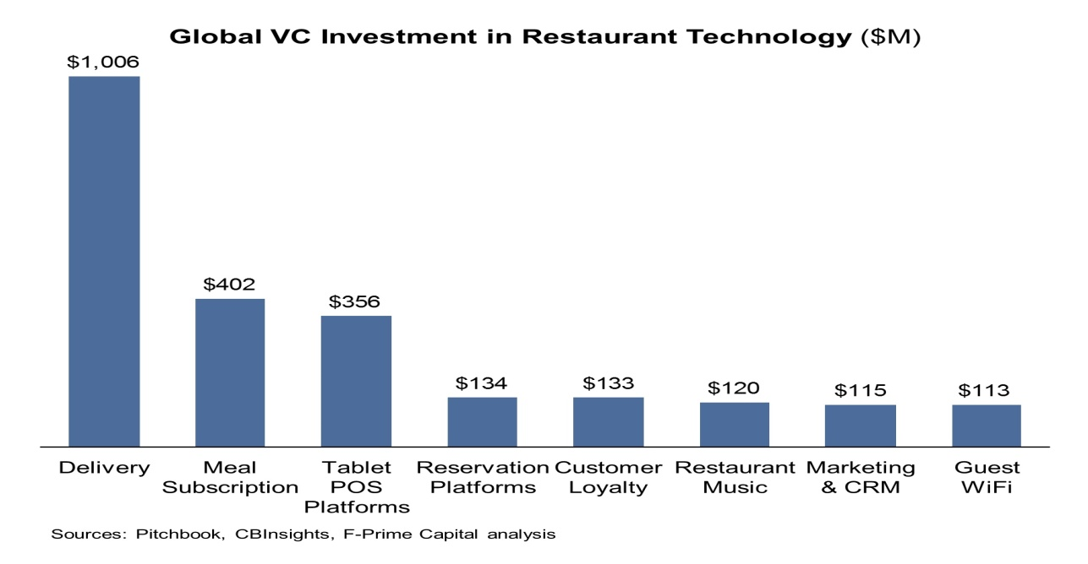

**What's Inside**

* Introduction
* Business Problem
* Data & Restaurant Service Styles
* Result & Business Plan
* Choosing a Location
* Observation
* Conclusion

Shifting demographics and changing lifestyles are driving the surge in food-service businesses. Busy consumers don't have the time or inclination to cook. They want the flavor of fresh bread without the hassle of baking. They want tasty, nutritious meals without dishes to wash. In fact, the rise in popularity of to-go operations underscores some clear trends in the food-service industry. More and more singles, working parents and elderly people are demanding greater convenience when it comes to buying their meals.

Though the future looks bright for the food-service industry overall, there are no guarantees in this business. Even the most successful operators will tell you this isn't a "get rich quick" industry. It's more like a "work hard and make a living" industry.

To help you get started, we've compiled this thorough, but easy-to-digest, guide to starting your own food business. Whether your dream is to open a traditional American diner, a New York-style pizzeria, a Chinese buffet, a deli for busy lunch-goers or a local coffeehouse/hang-out spot, start your business research here.

No single food-service operation has universal appeal. This is a fact that many newer entrepreneurs have trouble accepting, but the reality is that you will never capture 100 percent of the market. When you try to please everyone, you end up pleasing no one. So focus on the 5 or 10 percent of the market that you can get, and forget about the rest.

With that said, who is eating at restaurants? Let's look at the main market categories of food-service business customers:

* **Generation Y.** This generation, also tagged the "millennial generation," the "echo" or the "boomlet" generation, includes those born between 1980 and 2000. Generation Y is the most ethnically diverse generation yet and is more than three times the size of generation X. They are a prime target for a food-service business. Members of Generation Y go for fast-food and quick-service items. About 25 percent of their restaurant visits are to burger franchises, follow by pizza restaurants at 12 percent.
* **Generation X.** Generation X is a label applied to those who were born between 1965 and 1980. This group is known for strong family values. While earlier generations strove to do better financially than their parents, Gen Xers are more likely to focus on their relationship with their children. They are concerned with value, and they favor quick-service restaurants and midscale operations that offer all-you-can-eat salad bars and buffets. To appeal to this market group, offer a comfortable atmosphere that focuses on value and ambience.
* **Baby boomers.** Born between 1946 and 1964, baby boomers make up the largest segment of the U.S. population. Prominent in this generation are affluent professionals who can afford to visit upscale restaurants and spend money freely. During the 1980s, they were the main customer group for upscale, trendy restaurants. In the 1990s, many baby boomer were two-income households with children. Today, those on the leading edge of the boomer generation are becoming grandparents, making them a target of restaurants that offer a family-friendly atmosphere and those that provide an upscale, formal dining experience.
* **Empty nesters.** This group consists of people in the age range between the high end of the baby boomers and seniors (people in their early 50s to about age 64). Empty nesters typically have grown children who no longer live at home, and their ranks will continue to increase as the baby boomers grow older and their children leave home. With the most discretionary income and the highest per-capita income of all the generations, this group typically visits upscale restaurants. They are less concerned with price and are more focused on excellent service and outstanding food. Appeal to this group with elegant surroundings and a sophisticated ambience.
* **Seniors.** The senior market covers the large age group of people age 65 and older. Generally, the majority of seniors are on fixed incomes and may not often be able to afford upscale restaurants often, so they tend to visit family-style restaurants that offer good service and reasonable prices. "Younger" seniors are likely to be more active and have more disposable income than "older" seniors, whose health may be declining. Seniors typically appreciate restaurants that offer early-bird specials and senior menus with lower prices and smaller portions, since their appetites are less hearty than those of younger people.

**Restaurant Service Styles**

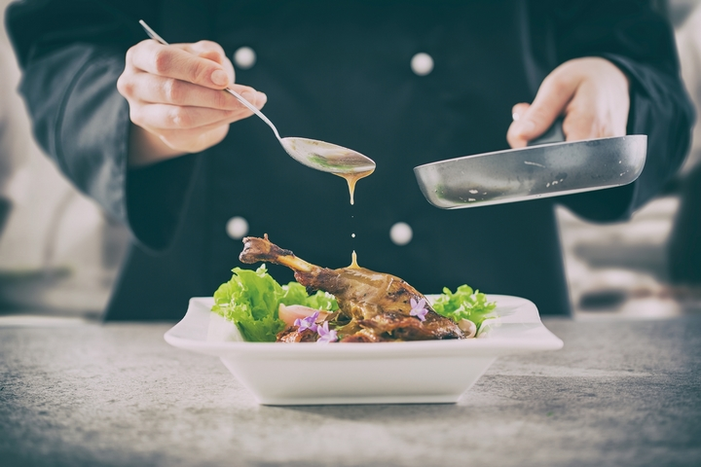

* Restaurants are classified into three primary categories: quick-service, midscale and upscale. Quick-service restaurants are also known as fast-food restaurants. These establishments offer limited menus of items that are prepared quickly and sold for a relatively low price. In addition to very casual dining areas, they typically offer drive-thru windows and take-out service.
* When people think of fast-food restaurants, they often think of hamburgers and french fries, but establishments in this category also serve chicken, hot dogs, sandwiches, pizza, seafood and ethnic foods.
* Midscale restaurants, as the name implies, occupy the middle ground between quick-service and upscale restaurants. They offer full meals but charge prices that customers perceive as providing good value. Midscale restaurants offer a range of limited- and full-service options. In a full-service restaurant, patrons place and receive their orders at their tables; in a limited-service operation, patrons order their food at a counter and then receive their meals at their tables. Many limited-service restaurants offer salad bars and buffets.
* Upscale restaurants offer full table service and do not necessarily promote their meals as offering great value; instead, they focus on the quality of their cuisine and the ambience of their facilities. Fine-dining establishments are at the highest end of the upscale restaurant category and charge the highest prices.

#### Selecting a Food Concept

Restaurant patrons want to be delighted with their dining experience, but they don't necessarily want to be surprised. If you're anticipating a family-style steakhouse (based on the name or the décor of the establishment), but you find yourself in a more formal environment with a bewildering--and pricey--gourmet menu, the surprise may keep you from enjoying the restaurant. Concepts give restaurateurs a way to let patrons know in advance what to expect and also to provide some structure for their operation. Here are some of the more popular restaurant concepts:

* **Seafood.** Quick-service seafood restaurants generally offer a limited range of choices, often restricted to fried seafood. Midscale and upscale seafood restaurants offer a wider selection, prepared in ways other than fried, such as baked, broiled and grilled. Seafood can be a risky area on which to focus, as prices are always changing, and many kinds of seafood are seasonal. Also, quality can vary tremendously. When shopping for seafood, make sure the items are fresh and meet your standards of quality. If you are not happy with what a distributor offers, you can be sure your customers won't be, either.
* **Steakhouses.** Steakhouses are part of the midscale and upscale markets. Midscale steakhouses are typically family-oriented and offer a casual environment with meals perceived as good values. In terms of décor, comfort is emphasized and Western themes are popular. Upscale steakhouses offer a more formal atmosphere and may serve larger cuts of meat that are of better quality than those served in midscale restaurants. Upscale establishments also charge higher prices, and their décor may be similar to that of other fine-dining establishments, offering guests more privacy and focusing more on adult patrons than on families.
* **Family-style restaurants.** As the name implies, these establishments are geared toward families. Since they charge reasonable prices, they also appeal to seniors. They offer speedy service that falls somewhere between that of quick-service places and full-service restaurants. Their menus offer a variety of selections to appeal to the interests of a broad range of customers, from children to seniors. Family-style restaurant prices may be higher than those at fast-food restaurants, but these establishments provide table service to compensate. The décor of family-style restaurants is generally comfortable, with muted tones, unremarkable artwork, and plenty of booths and wide chairs. Booster seats and highchairs for children are readily available.
* **Casual-dining restaurants.** These establishments appeal to a wide audience, ranging from members of Generation Y to Generation X to baby boomers with families to seniors, and they provide a variety of food items, from appetizers and salads to main dishes and desserts. Casual-dining restaurants offer comfortable atmospheres with midrange prices. Many center on a theme that's incorporated into their menus and décor.
* **Ethnic restaurants.** Ethnic restaurants enjoy a significant share of the U.S. restaurant market. They range from quick-service places with limited selections to upscale eateries with a wide variety of menu items. Their menus typically include Americanized versions of ethnic dishes, as well as more authentic food. The three most popular kinds of ethnic restaurants are Italian, Chinese and Mexican. Other popular ethnic restaurant types include Indian, Thai, Caribbean, English, French, German, Japanese, Korean, Mediterranean and Vietnamese. An even wider variety of ethnic restaurants can thrive in areas with a culturally diverse population, such as large metropolitan areas.
* **Pizzeria.** You have two primary choices when entering starting a pizzeria. One is a to-go restaurant in a modest facility with a specialized menu highlighted by pizza and beer, limited seating and a self-service atmosphere. The other is a full-service pizza restaurant with a menu that features not only a variety of pizzas, beer and wine, but also Italian entrees like spaghetti, ravioli and lasagna, side dishes such as salads (or even a salad bar), and a few desserts. The foundation of a pizzeria is, of course, the pizza. If you don't know how to make a good pizza, hire a good pizza cook who does. Invest in top-quality ingredients and preparation methods, and make every pizza as if you're going to eat it yourself. Do that, and your customers will keep coming back for more.
* **Sandwich Shop/Delicatessen.** One reason sandwich shops are so successful is that they enjoy high profit margins. Sandwich shops and delicatessens can also change their menus quickly and easily to adapt to current tastes. For example, with the growing interest in health and nutrition in the United States, sandwich shops and delicatessens have started offering more low-fat, healthy ingredients in their sandwiches, salads and other menu items. In addition, many sandwich shops and delis have been able to keep up with workers who eat at their workplaces by adding delivery and catering to their sit-down and take-out operations. Sandwich shops and delicatessens can be differentiated by the foods they serve. Most sandwich shops serve only sandwiches, possibly with some side dishes or desserts. A delicatessen usually offers a more extensive menu, including sandwiches, prepared meats, smoked fish, cheeses, salads, relishes and various hot entrees.
* **Coffeehouse.** With more than 400 billion cups consumed every year, coffee is the world's most popular beverage. But beyond the beverage itself, people frequent coffeehouses and espresso bars for a variety of reasons: to meet with friends, for a quick lunch and a drink to perk up the afternoon, or simply to start off each morning with a great cup of coffee to start off each morning. Most successful coffeehouses have heavy foot traffic and high-volume sales. The majority will serve up to 500 customers per day and manage up to five customer turnovers during the lunch hour, despite having limited floor space and modest seating capacity. Profit margins for coffee and espresso drinks are extremely high--after all, you're dealing with a product that's more than 95 percent water. At the same time, your average ticket amount is around $3, so you need volume to reach and maintain profitability. Besides specialty roasted coffee by the cup, most coffeehouses also have espresso-based drinks (cappuccinos, lattes, etc.), assorted teas, bottled water and fruit juices, along with an inviting assortment of baked goods, a selection of desserts, and coffee beans by the pound.
* **Bakery.** With the emergence of strip malls and competition from supermarkets that have in-store bakeries, "bread-only" retail bakeries have almost disappeared from the United States. Bakeries today offer cakes, scones, bagels and coffee drinks, and sometimes even offer full dining menus, including sandwiches, hot entrees, beer and wine. Consumers love fresh bakery goods, but the market is extremely competitive. As you develop your particular bakery concept, you'll need to find a way to differentiate yourself from other bakeries in town.

## Writing a Business Plan

Armed with practical experience, you're ready to put together your business plan--the most critical element of your restaurant. Map out everything on paper before you buy the first spoon or crack the first egg.

When you're [writing a business plan](https://www.entrepreneur.com/businessplan/) you should include: a clear definition of your concept; a description of your market; your menu and pricing; detailed financial information, including data on your startup capital (amount and sources) and your long-term income and expense forecasts; a marketing plan; employee hiring, training and retention programs; and detailed plans that outline how you'll deal with the challenges restaurateurs face every day. Including an exit plan in your strategy is also a good idea.

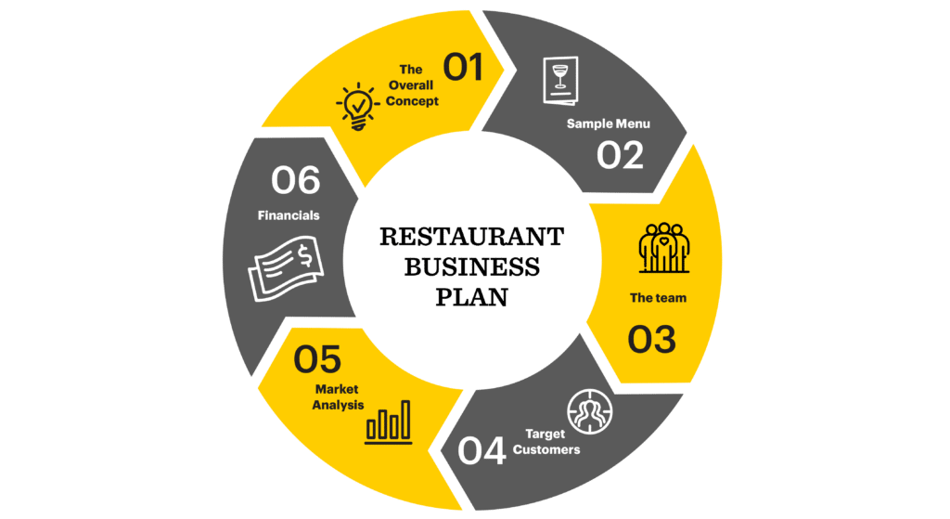

**Funding Your Business**

How much money you need to start depends on the type of business, the facility, how much equipment you need, whether you buy new or used, your inventory, marketing, and necessary operating capital (the amount of cash you need on hand to carry you until your business starts generating cash). It's easy to spend hundreds of thousands of dollars starting a restaurant, but it's not essential. For instance, when Borealis Breads owner Jim Amaral started his first bakery in Maine, he rented a space that had been a commercial bakery and came complete with mixers, benches, ovens and other equipment. He was able to start with just $10,000 he'd borrowed from family and friends, and used that primarily for inventory.

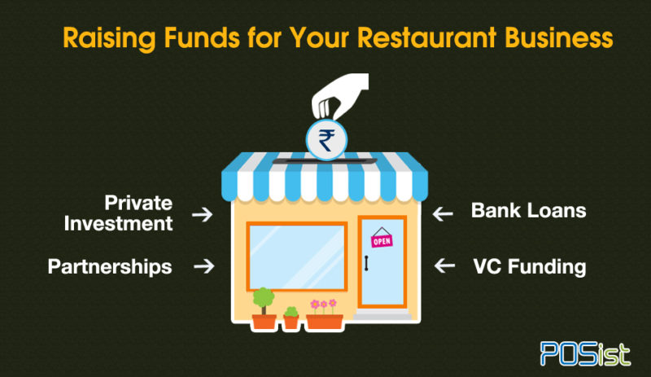

Regardless of how much you need, you will definitely need some cash to start your food-service business started. Here are some suggestions of where to go to raise your startup funds:

* **Your own resources.** Do a thorough inventory of your assets. People generally have more assets than they realize, including savings accounts, retirement accounts, equity in real estate, recreation equipment, vehicles, collections and other investments. You may opt to sell assets for cash or use them as collateral for a loan. Also look at your personal line of credit. Many a successful business has been started with credit cards.
* **Family and friends.** The logical next step after gathering your own resources is to approach friends and relatives who believe in you and want to help you succeed. Be cautious with these arrangements; no matter how close you are with the person, present yourself professionally, put everything in writing, and be sure the individuals you approach can afford to take the risk of investing in your business.
* **Partners.** Using the "strength in numbers" principle, look around for someone who may want to team up with you in your venture. You may choose someone who has financial resources and wants to work side by side with you in the business. Or you may find someone who has money to invest but no interest in doing the actual work. Be sure to create a written partnership agreement that clearly defines your respective responsibilities and obligations. And choose your partners carefully--especially when it comes to family members.
* **Government programs.** Take advantage of the abundance of local, state and federal programs designed to support small businesses. Make your first stop the SBA, but be sure to investigate various other programs. Women, minorities and veterans should check out special financing programs designed to help them get into business. The business section of your local library is a good place to begin your research.

## Choosing a Location

Depending on how much money you have to invest in your food-service business and the particular type of business you choose, you can spend anywhere between $70,000 and $1.5 million on a facility.

Not every food-service operation needs to be in a retail location, but for those that do depend on retail traffic, here are some factors to consider when deciding on a location:

* **Anticipated sales volume.** How will the location contribute to your sales volume?
* **Accessibility to potential customers.** Consider how easy it will be for customers to get into your business. If you are relying on strong pedestrian traffic, consider whether or not nearby businesses will generate foot traffic for you.
* **The rent-paying capacity of your business.** If you've done a sales-and-profit projection for your first year of operation, you will know approximately how much revenue you can expect to generate, and you can use that information to decide how much rent you can afford to pay.
* **Restrictive ordinances.** You may encounter unusually restrictive ordinances that make an otherwise strong site less than ideal, such as limitations on the hours of the day that trucks can legally load or unload.
* **Traffic density.** With careful examination of food traffic, you can determine the approximate sales potential of each pedestrian passing a given location. Two factors are especially important in this analysis: total pedestrian traffic during business hours and the percentage of it that is likely to patronize your food service business.
* **Customer parking facilities.** The site should provide convenient, adequate parking as well as easy access for customers.
* **Proximity to other businesses.** Neighboring businesses may influence your store's volume, and their presence can work for you or against you.
* **History of the site.** Find out the recent history of each site under consideration before you make a final selection. Who were the previous tenants, and why are they no longer there?
* **Terms of the lease.** Be sure you understand all the details of the lease, because it's possible that an excellent site may have unacceptable leasing terms.
* **Future development.** Check with the local planning board to see if anything is planned for the future that could affect your business, such as additional buildings nearby or road construction.

**Layout**  
Layout and design are major factors in your restaurant's success. You'll need to take into account the size and layout of the dining room, kitchen space, storage space and office. Typically, restaurants allot 45 to 65 percent of their space to the dining area, approximately 35 percent to the kitchen and prep area, and the remainder to storage and office space.

* **Dining area.** This is where you'll be making the bulk of your money, so don't cut corners when designing your dining room. Visit restaurants in your area and analyze the décor. Watch the diners; do they react positively to the décor? Is it comfortable, or are people shifting in their seats throughout their meals? Note what works well and what doesn't.

Much of your dining room design will depend on your concept. It will help you to know that studies indicate that 40 to 50 percent of all sit-down customers arrive in pairs; 30 percent come alone or in parties of three; and 20 percent come in groups of four or more.

To accommodate the different groups of customers, use tables for two that can be pushed together in areas where there is ample floor space. This gives you flexibility in accommodating both small and large parties. Place booths for four to six people along the walls.

* **Production area.** Too often, the production area in a restaurant is inefficiently designed--the result is a poorly organized kitchen and less than top-notch service. Keep your menu in mind as you determine each element in the production area. You'll need to include space for receiving, storage, food preparation, cooking, baking, dishwashing, production aisles, trash storage, employee facilities and an area for a small office where you can perform daily management duties.

Arrange your food production area so that everything is just a few steps away from the cook. Your design should also allow for two or more cooks to be able to work side by side during your busiest hours.

**Conclusion**

* [***Restaurant and More: Step-By-Step Startup Guide***:](https://bookstore.entrepreneur.com/product/start-your-own-restaurant-4e/?cam=refinit&ctp=bookstore&src=bookstore_text_relate) *Entrepreneur*'s official guide describes the ins and outs of starting and running a successful restaurant, pizzeria, coffeehouse, deli, bakery or catering service. Packed with tips on how to keep your restaurant growing and healthy, the book answers most commonly asked questions and covers the essential business basics.
* [**The Menu Maker**](http://www.themenumaker.com/): Having trouble creating that memorable menu for your restaurant? This site specializes in spicing up menus to increase your profits, complement your eatery and reinforce your desired image. It also offers tips for menu presentation and helps determine your menu needs.
* [**National Restaurant Association (NRA)**](http://www.restaurant.org/): Founded in 1919, the NRA is the leading business association for the restaurant industry. Its site offers access to an information service and library, various publications and industry research. It also provides networking opportunities and training, and emphasizes the ways in which local restaurants can contribute to their communities.
* [**National Restaurant Association (NRA) Educational Foundation**](http://www.nraef.org/): This nonprofit organization is dedicated to fulfilling the NRA's educational mission. The site offers classes for professionals and listings of U.S. Food Safety Regulatory System laws and training requirements. Where available, county and municipal requirements are also listed.
* [**PlanMagic Restaurant**](http://www.plan-a-restaurant.com/): This comprehensive package is geared toward startup restaurants. It focuses on methods for writing a successful business plan, and helps you figure out specific financial calculations to beef up your proposal.
* [**Restaurant Associations (by State)**](http://www.restaurant.org/states/index.cfm): Find out state-specific information regarding the restaurant and food-service industry.
* [**Restaurant Business Plan from Bplans.com**](http://www.bplans.com/st/restaurant.cfm): This site is a collection of resources and tools for starting a restaurant, including a restaurant industry report, sample restaurant business plans and a link to a local Small Business Development Center finder.
* [**Restaurantfunds**](http://www.restaurantfunds.com/): This website allows you to order a package called the Restaurant Success Kit, which includes a restaurant business plan creation tool, restaurant financials creation software, and a complete e-book and user's manual to help answer all your restaurant questions.
* [***Restaurant Startup & Growth* magazine**](http://www.restaurantowner.com/): Here you'll find resources to help you get organized, increase sales, reduce theft, control costs, improve service, hire better employees, safeguard your cash and much more.
* [**Service Corps of Retired Executives (SCORE)**](http://www.score.org/): To get some practical, real-world advice, contact SCORE and ask to speak with small-business counselors who owned or managed a restaurant. Find offices or counselors in your area by visiting the website.
* [**Women's Foodservice Forum (WFF)**](http://www.womensfoodserviceforum.com/): The WFF is dedicated to providing women in the food-service industry with the resources to succeed. It offers leadership development programs, market research, and a regional partnership program for networking. The site also provides answers to FAQs, advice and a community of peers.

**-------------------------------------------------------------------**